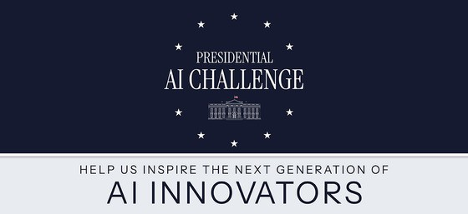

[Your Museum/Library Name] Invites Local Youth and Educators to Join the Presidential AI Challenge
Calling all creative problem-solvers! The Presidential AI Challenge is a new nationwide initiative inviting K–12 students, educators, mentors, and community teams to harness the power of artificial intelligence to tackle real-world challenges in their communities.
Hosted at the national level, this challenge is more than a competition, it’s a call to action to inspire the next generation of innovators. [Your Museum/Library Name] is proud to support this exciting opportunity and encourages youth and educators in our community to participate.
Why It Matters
- Build Future-Ready Skills: Participants will gain foundational knowledge in AI and digital literacy—skills that are vital in today’s tech-driven world.
- Support Educators: Teachers and mentors will receive resources to guide students through this dynamic and evolving field.
- Connect with Experts: Teams will have access to AI professionals from industry and government for mentorship, coaching, and collaboration.
- Expand Access: Free training, toolkits, and support materials will be made available to ensure equitable participation.
Key Details
- Who Can Join: Youth teams in grades K–12. Each team must include a supervising adult (such as a parent, educator, mentor, or community leader). Educator teams are also eligible.
- Registration Opens: September 2025
- More Information: Learn how to complete the challenge
[Your Museum/Library Name] will be offering [info sessions/workshops/mentor matching/resource support] to help local teams get started. Whether you’re new to AI or already exploring its possibilities, this is your chance to apply creativity and technology to make a difference.
For more information or to get involved locally, contact us at [email/contact info] or visit [your website link].
Let’s work together to shape the future—one idea at a time.

